**COMPARATIVE ANALYSIS OF SKIN DISEASE IN DIFFERENT DEEP LEARNING MODELS**

**Prof. (Dr.) Rashel Sarkar, Akansha Jain*, Sarungbam Alen Meetei\***

**\*Department of Computer Science and Technology, Royal School of Engineering and Technology, The Assam Royal Global University, Guwahati, Assam**

***Abstract-*** *This study examines three CNN architectures- ConvNeXt, ResNet50 and DenseNet121 for skin lesion classification on the HAM10000 dataset. This research employs techniques such as data augmentation, transfer learning and image segmentation to enhance each model’s ability to handle variability in image. The study evaluates the three models on various parameters such as – accuracy, precision, recall, f1-score– to access the strengths and limitations of each model. This evaluation provides us with the model that has the most effective approach and efficient results in skin lesion classification.*

**1. Introduction**

Skin cancer is the most common type of cancer globally. The incidence rate of skin cancer has been increasing rapidly over the decades; hence the urgent need for effective prevention and detection measures. With the advancements in technology, the survival rates have increased, however precise diagnosis remains crucial for better and optimal outcomes. Melanoma, one of the deadliest skin cancers. It is very challenging to treat this disease when diagnosed late or to limited access to dermatology specialists due to high likelihood of metastasis. If the disease is not diagnosed early, the survival rate of an individual post-diagnosis will be a maximum of five years. However, detecting the disease at an early stage not only increases the survival rates but also offers nearly a 100% recovery probability, The slight difference across the skin lesion that can occur due to various factors such as slight difference in lighting, difference in skin types, age of an individual, and other environmental factors may lead to misdiagnosis despite the advancements in detection technologies. Dermoscopy has become an important tool that provides a more detailed and standardized view of skin lesions, improving the diagnostic accuracy for healthcare and professionals.

The application of deep learning in medical images has been explored extensively, as highlighted by (1) Jijaji Wang (2023) in their survey on deep learning’s impact on medical image analysis, which outlines the transformative role of CNNs in analyzing complex data on skin disease classification. (2) Lubna Farhi (2022) applied Deep Belief Networks for dermoscopic image classification, demonstrating the flexibility and effectiveness of diverse neural architectures in distinguish between benign and malignant lesions. (3) Cheng- Hong Yan (2021) introduced a deep hybrid CNN model specifically designed for melanoma lesion segmentation, illustrating the model’s capability in enhancing segmentation accuracy for improved diagnosis. (4) Risheng Wang (2021) provided a comprehensive survey on the use of deep learning techniques, which has proven instrumental in tasks requiring precise identification of affected regions in medical images.

Artificial Intelligence (AI) has emerged as a powerful tool by providing insights on patterns recognition capabilities that supports the doctors from identifying potential malignancies. (5) Ismail Oztel (2023) developed a smartphone compatible deep learning models, emphasizing the importance of accessible and mobile solutions for diagnosis in remote and resource-limited settings. Though AI algorithms have a significance in this context, clinicians still play a crucial role in validating these findings, incorporating the patient’s history and lifestyle into the findings. This integration between AI and the clinical staff not only optimizes the diagnostic flow but also provides faster and data-supported insights to patients. Yet, several challenges persist in implementing effective AI-driven diagnostic tools. The need for vast, well-labelled dataset is paramount, which is one of the problems, because each cancer type has a different incidence number as well as image examples, leading to an imbalance between skin cancer classes leading to uneven data representation.

Our research addresses this problem by testing the models on a standardized skin disease dataset and evaluating the performance of each model based on its accuracy, precision, sensitivity, recall, f1-score and computation power to identify the most suitable architecture for accurate and efficient skin disease classification.

**Keywords: Skin Cancer, CNN, Deep Learning, Artificial Intelligence, Dermoscopy**

**2. Background Study**

In (6), the study demonstrated that using wrapper-based feature selection, particularly the Grey Wolf Optimization (GWO) algorithm, yielded the highest classification performance, achieving an accuracy of 83.33% on the ISIC dataset and 93.50% on the ISIC 2018 dataset.

In (7), the study utilized a Deep Belief Learning (DBL) network architecture that achieved significant improvements in classification accuracy, especially on segmented dermoscopic images, with accuracy gains ranging from 8% to 47% over other models like AlexNet and LeeNet and segmented images classified with the DBL network also exhibited reduced error rate by 41.5% and faster processing times, focusing on weight distribution on the clustered regions rather than the whole image.

In (8), the study hights that CNN-based models, such as ResNet and EfficientNet, provide robust results for skin lesion classification with accuracy reaching up to 93.65%.

In (9), The proposed hybrid model (a combination of DeepLabV3+, MobileNetV2, EfficientNetB0 and DEnseNet201) achieved an accuracy of 94.42% and an F1 score of 93.49% on the ISIC-2019 dataset, and an accuracy of 94.44% on the PH2 dataset, conforming its generalizability.

In (10), the model used are EfficientNetv2B0, Regnet x006, InceptionResnetv2. The EfficientNetv2 B0 model achieved the best overall performance across multiple classification tasks with an accuracy rate as high as 92.9% for specific binary classifications, enhancing both sensitivity and specificity.

In (11), the models used are ResNet18. EfficieNetB3, MobileNetv2. The study achieved a 74.27% classification accuracy on a seven-class skin disease dataset, including MonkeyPox, using a TensorFlow Lite version of ResNet18.

**3. Methodology**

The following section provide a description of the dataset used, the techniques applied and the architecture of each model.

**Dataset Collection:** This project utilizes the HAM10000 dataset, chosen for its high-quality, dermatologist-reviewed images, which enhances the reliability of skin lesion classification. It includes a diverse collection of 10,015 images, but only7470 unique lesions, as duplicate images were removed to maintain the data integrity and prevent biased training outcomes.

The dataset consists of Actinic Keratoses (327 Images), Basal Cell Carcinoma (514 images), Benign Keratosis (1099 images), Dermatofibroma (115 images), Melanocytic nevi (6705 images), Melanoma (1113 images), and Vascular lesion (142 images), totalling to 10,015 images.

**Fig. 3.1** Seven distinct skin lesions in HAM10000 dataset

**Preprocessing of Dataset:** It is an important step for preparing raw data for deep learning models. The techniques used are removing duplicates, resizing and rescaling and removing noise.

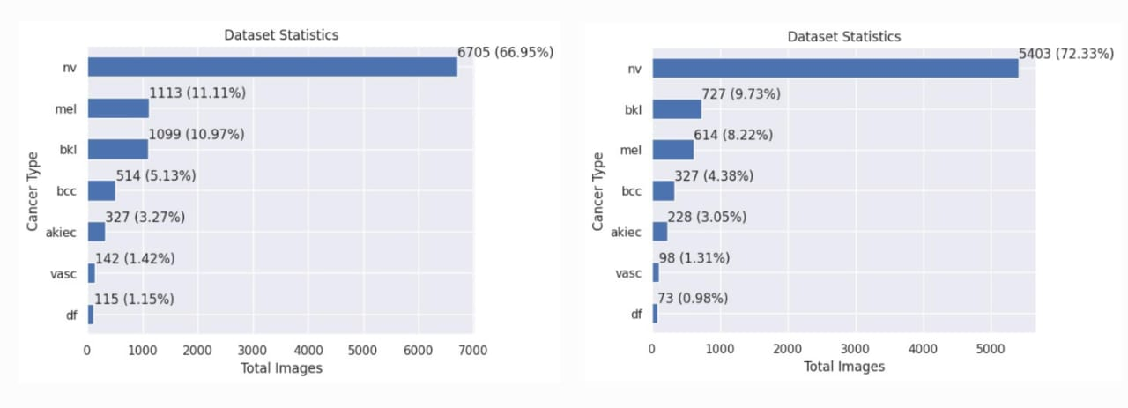

**Fig. 3.2:**  Dataset distribution classes, on the left side of the graph the raw dataset and on the right side the removed duplicate images.

**Data Augmentation:** It is the process of artificially expanding the size and diversity of training dataset by applying various transformation to the images. The various data augmentation techniques used are rotation, H-flip and V-flip, zooming, shearing, width shift, height shift and channel shift.

**Fig. 3.3:** Dataset distribution after data augmentation

**Transfer Learning:** Transfer learning is a technique that solves related task using pre-defined model. It helps in solving new problems with smaller dataset by using knowledge of the model that has been trained on a large and diverse dataset. By using these pre-trained weights, transfer learning speeds up the model training process and improves the accuracy. In this study, transfer learning is used to fine-tune the models where the original data serves as the foundation. Here, we allow the weights to be adjusted during the training process, thus ensuring that the model adapts itself to the varied representation of the medical images. This approach helps in improving the key performance metrics, providing more accurate and efficient diagnosis. The fine-tuning of the model is highly effective as it helps in capturing the disease-affected feature and enhancing the model’s ability to recognize subtle differences in skin condition.

**4. Model Architecture**

This project evaluates the performance of three Convolutional Neural Networks (CNN) architectures: ConvNeXt, ResNet50, and DenseNet121. The details on each of the architecture are provided below.

**ConvNeXt:** ConvNeXt was developed in 2020s, inspired by the Vision Transformer. The ConvNeXt-Base architecture consists of 12 stages, with convolutional layers integrated into its design to achieve efficient feature extraction. It uses approximately 89 million parameters, enabling the model to effectively capture complex patterns in images. Designed for 224x224 pixel input images, ConvNeXt is compatible with a wide range of pre-trained models. This architecture excels in scenarios requiring robust and high-quality feature extraction. By combining the high accuracy of Vision Transformers with the computational efficiency and simplicity of convolutional neural networks (CNNs), ConvNeXt stands out as an efficient and powerful model for computer vision tasks.

**Fig. 4.1:** ConvNeXt-Base Model Architecture

**ResNet50:** ResNet50 is variant of ResNet family. ResNet50 comprises of an initial convolution and pooling layer followed by four stages of residual blocks, totalling to 50 layers. ResNet50 was developed to help mitigate the vanishing gradient which is a problem that occurs in deeper networks. In traditional deeper networks, as layers increase, the gradients decrease during backpropagation leading to difficult in training. This problem is handled by the residual block of ResNet50 that incorporates shortcuts connection to “skip” certain layers. This architecture uses approximately 25.5 million parameters and works efficiently with images at 224x244 pixel resolution. Its strong balance between depth and efficiency makes it an effective model for image recognition.

**Fig. 4.2:** ResNet50 Model Architecture

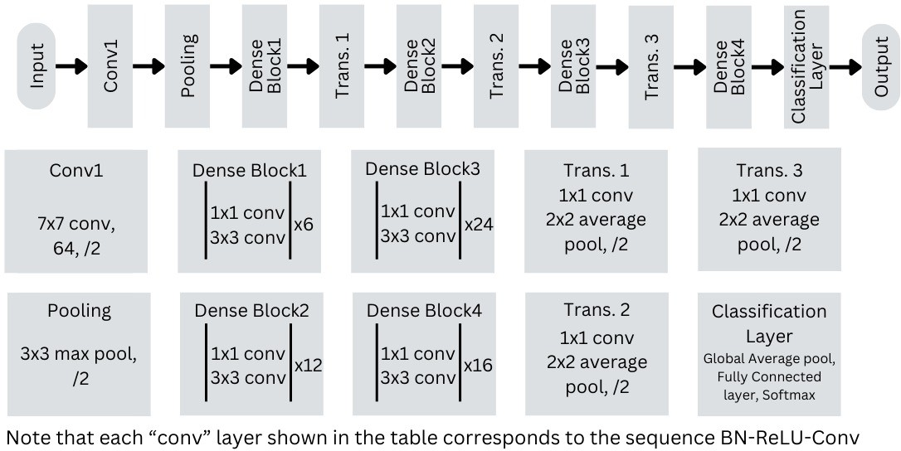**Densenet121:** DenseNet121 is a variant of Dense Convolutional Network (DenseNet) architecture. DenseNet121 is known for its innovative design where each layer connects to every subsequent layer, creating a “dense” connectivity pattern, unlike traditional CNN where each layer connects only to the previous and the next layer. Densenet121 consists of an initial convolutional and pooling layer followed by four dense blocks and transition layers, totalling to 121 layers. This architecture uses approximately 8 million parameters and works efficiently with images of 244x244 pixel resolution. The innovative design of DenseNet121 allows better feature reuse and efficient gradient flow, thus making DenseNet121 an efficient and powerful model for image recognition tasks.

**Fig. 4.3:** DenseNet121 Model Architecture

**5. Training:**

A configurable notebook is created for this project, to centralize the main settings for each training model. Each model was tested with the dataset imported via Kaggle’s Dataset, using only the TPU to train the model, resulting sub-30 minutes of training time to conclude a single execution of the notebook. In this stage, the images are divided into three sets: training, validation, and testing with the respective rates: 70%, 10%, and 20%. The exact number of images for each class is represented in the Fig. 5:

**Fig. 5:** Dataset distribution between training, validation and test sets

**6. Results:**

This study evaluates the performance of – ConvNeXt, ResNet50 and DenseNet121 on HAM10000 dataset using key metrics – accuracy, precision, recall, F1-score and specificity – after training on augmented and segmented images. All the three models had a variety of combination are the overall performance metrics are displayed in the Fig. 9. Only those combinations are taken that achieved an accuracy of more than 50%. The study revealed that ConvNeXt achieved the highest accuracy of 96.45% demonstrating robust feature extraction capabilities suitable for complex medical images, followed by ResNet50 with an accuracy of 96.03% with its residual blocks effectively vanishing the gradient problem, and DenseNet121 achieved an accuracy of 88.62% excelling in its innovative design allowing better feature reuse and efficient gradient flow. In conclusion, ConvNeXt was found to be the most suitable architecture for handling variability and complexities in skin lesions, making it the top performing model in comparative analysis.

**Fig. 6.1:** Performance metrices for different combinations of three models

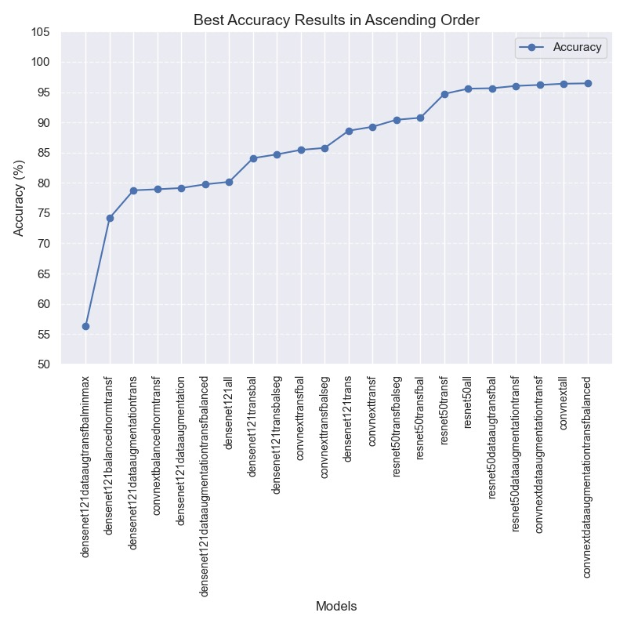

**Fig. 6.2:** Graph representing best model training accuracies

**7. Conclusion and Future Work**

In summary, each model has their unique strengths in skin disease classification with ConvNeXt having the highest accuracy and leading in terms of overall performance. ConvNeXt is a very efficient model where high accuracy and speed are required. While DenseNet121 and ResNet50 also performed well, their architecture are more suited for environments where memory and computational limitations are less important. To improve further accuracy, future research can investigate on model ensembles that incorporate ConvNeXt, DenseNet121 and ResNet50. It may also involve adding hybrid models that increases the sensitivity to subtle image features. Further broadening the study to a wider range of skin disease and more diverse dataset can increase the efficacy of the model.

**References**

1. Jiaji Wang, Shuihua Wang, Yudong Zhang. Deep learning on medical image analysis. 2023. doi: 10.1049

2. Lubna Farhi, Saadia Mansoor Kazmi, Hassan Imam, Mejdal Alqahtani, Farhan Ur Rehman. Dermoscopic Image Classification Using Deep Belief Learning. 2022. doi:10.1155

3. Cheng-Hong Yan, Jai-Hong Ren, Hsiu-Chen Huang, Li-Yeh Chuang, Po-Yin Chang. Deep Hybrid Convolutional Neural Network for Segmentation of Melanoma Skin Lesion. 2021. doi:10.1155

4. Risheng Wang, Tao Lei, Ruixia Cui, Bingtao Zhang, Hongying Meng, Asoke K. Nandi. Medical image segmentation using deep learning: A survey. 16, 2021. doi:10.1049

5. Ismail Oztel, Gozde Yolcu Oztel, Veysel Harun Sahin. Deep Learning‐Based Skin Diseases Classification using Smartphones. 5, 2023. doi:10.1002

6. Ahmet Nusret Toprak, Ibrahim Aruk. A Hybrid Convolutional Neural Network Model for the Classification of Multi‐Class Skin Cancer. 11, 2024. doi:10.1002

7. Dulani Meedeniya, Senuri De Silva, Lahiru Gamage, Uditha Isuranga. Skin cancer identification utilizing deep learning: A survey. 2024. doi:10.1049

8. Elif Nur Haner Kırğıl, Çağatay Berke Erdaş. Enhancing Skin Disease Diagnosis Through Deep Learning: A Comprehensive Study on Dermoscopic Image Preprocessing and Classification. 34, 2024. doi:10.1002

9. Farzad Golnoori, Farsad Zamani Boroujeni, Seyed Amirhassan Monadjemi. A comparative study on deep feature selection methods for skin lesion. 18, 2023. doi:10.1049

10. Tsedenya Debebe Niga, Tilahun Melak Sitote, Berihun Molla Gedefaw. Fungal Skin Disease Classification Using the Convolutional Neural. 2023. doi:10.1155

11. Ellak Somfai, Benjamin Baffy, Kristian Fenech, Rita Hosszú, Dorina Korozs, Marcell Polik, Miklos Sardy, Andras Lorincz. Handling dataset dependence with model ensembles for skin lesion classification. 33, 2023. doi:10.1002